**Name: Dev Patel**

**Enrollment No.: MITU21BTCS0184**

**Roll No.: 2213142**

**Problem Statement 3(a):**

Write a JavaScript code to take inputs from user and display that inputs in following pattern “Hello ……… Welcome To World of JavaScript”.

JS Code:

var userInput = prompt("Enter your name:");

if (userInput !== null && userInput.trim() !== "") {

    var inputname = "Hello " + userInput + " Welcome To World of JavaScript";

    console.log(inputname);

} else {

    console.log("Invalid input");

}

HTML Code:

<!DOCTYPE html>

<html lang="en">

  <head>

    <meta charset="UTF-8" />

    <meta name="viewport" content="width=device-width, initial-scale=1.0" />

    <meta http-equiv="X-UA-Compatible" content="ie=edge" />

    <title>INPUT USER NAME</title>

    <style>

      body {

        height: 100vh;

        display: flex;

        align-items: center;

        background: linear-gradient(to top left, #32a1d0, #a9d8ff);

      }

      h1 {

        font-family:'Franklin Gothic Medium', 'Arial Narrow', Arial, sans-serif;

        font-size: 70px;

        width: 100%;

        padding: 30px;

        text-align: center;

        color: white;

      }

    </style>

  </head>

  <body>

    <h1>INPUT USER NAME</h1>

   <script src="3.js"></script>

  </body>

</html>

Explanation :

1. **var userInput = prompt("Enter your name:");**:

This line displays a pop-up dialog box in the user's browser with the message "Enter your name:". The user is expected to type in their name and click "OK" or press "Enter."

1. **if (userInput !== null && userInput.trim() !== "") {**: This line begins an "if" statement. It checks whether the value stored in the **userInput** variable is not null (meaning the user didn't click the "Cancel" button on the pop-up) and whether the input, after removing any leading or trailing spaces using **.trim()**, is not an empty string.
2. Inside the "if" block:
   * **var inputname = "Hello " + userInput + " Welcome To World of JavaScript";**: This line creates a new string by combining the text "Hello," the user's input (their name), and "Welcome To World of JavaScript." The resulting string is stored in the **inputname** variable.
   * **console.log(inputname);**: This line outputs the content of the **inputname** variable to the browser's console.

**OUTPUT 1:**

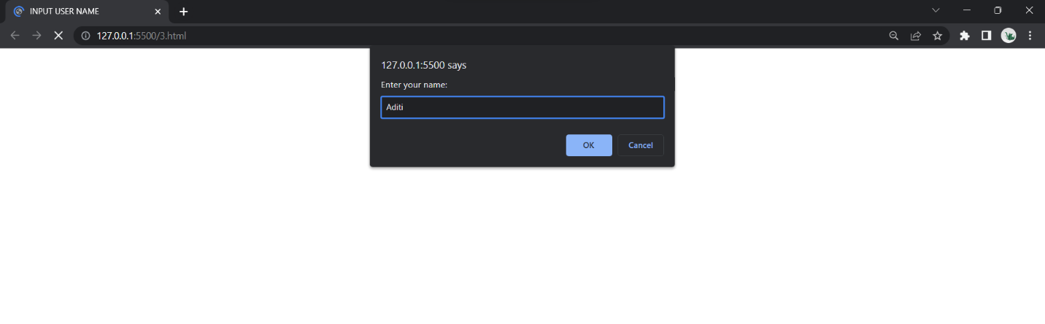

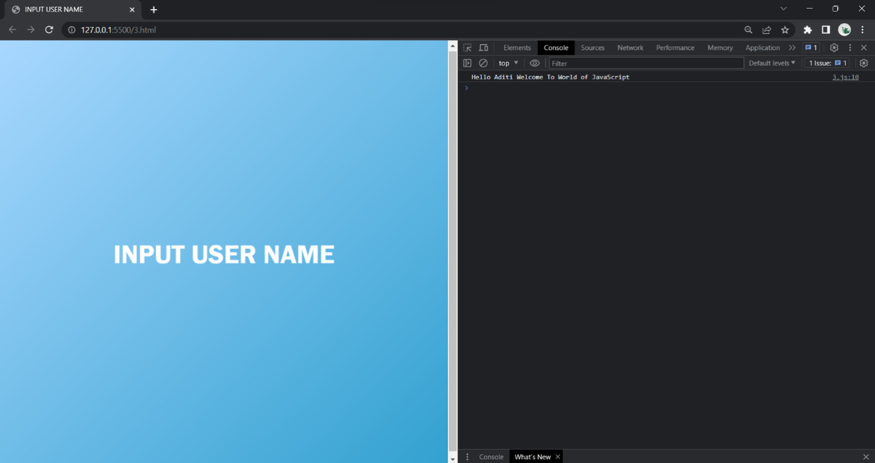

[console displays the welcome message]